

|  |  |
| --- | --- |
| Employee Name: | MANOJ KUMAR YEKOLLU |
| Training Supervised by: | **KRISHNA BODDULURI** |
| Training Task #: | **ASSIGNMENT10012019** |
| Training Resource Materials: | **Udemy – REST API Course** |
| Training Task Date: | **10/01/2019** |
| Task Due Date: | **10/15/2019** |
| Task Submitted Date: | **10/15/2019** |
| Github link: |  |
| Technologies used for Training | **REST** |

**Task Description/Requirement:**

**Learn and Document REST Concepts**

**High Level Synopsis:**

**REST API Concepts:**

* **Evolution of REST /JSON API**
* **RESTful Architectural Constraints**
* **Richardson Maturity Model**
* **Case Study: ACME Travels**
* **Creating an database instance in MongoDB Atlas.**

1. **ACME Travels Case Study:**

* All business over phone usually
* Developed a Website and Mobile app
* Mobile app got bad review because its showing incorrect data.
  + Competitors is talking away their customer with cool apps and good offers.

Current State:

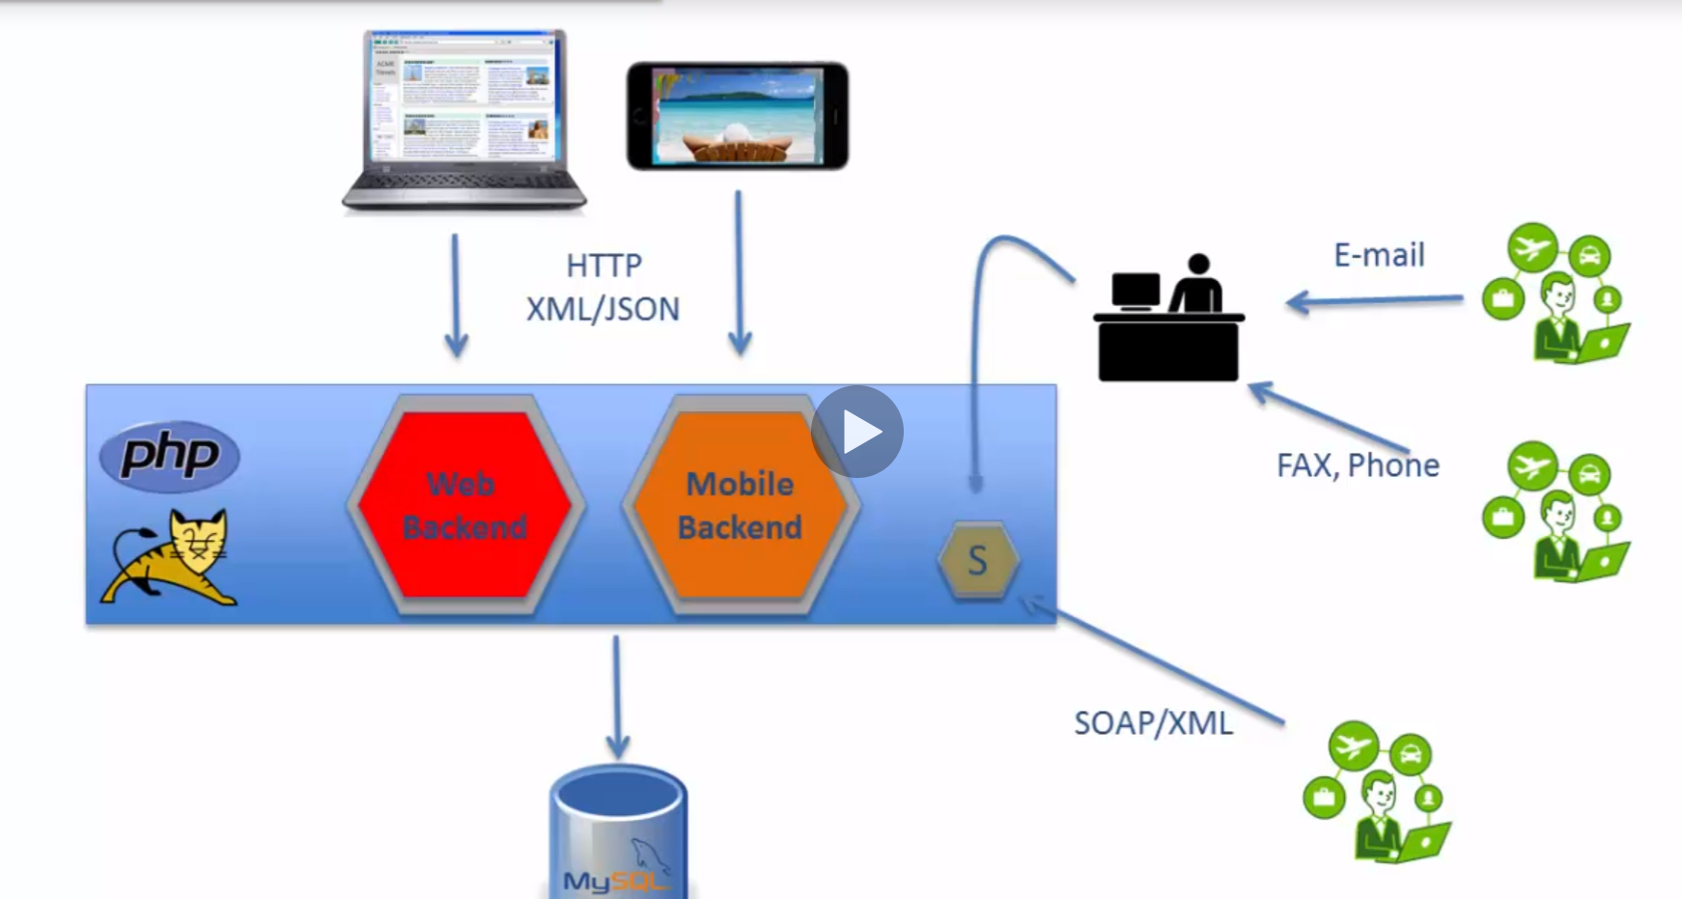

* ACME has a web browser app and a mobile app.
* It has backend code in PHP and a Tomcat server.
* It has two different backend for web and mobile. There is no code sharing between the two backends
* The data will store in MySQL.
* There will be a person who will receive the vacation data through the email, fax, phone. And he will get the data from db and update the records.
* ACME received lot of negative feedback from the customers because of this architecture.
* ACME also decided to release a SOAP based webservice for agent based and customer-based interaction, that didn’t work well either.

Solution:

Taget Architecure:

* Data will be managed in both MongoDb and MySQL
  + All the Vacation related data will be stored in MongoDB
  + All the Transaction related data will be store in MySQL.
* The Layer will be create using APIS which will interact with both MongoDB and MySQL databases.
* These APIs are common for both mobile app and the browser app.
* Agents will get their Own application, they can interact with the backend with the APIs.
* Even Partner also can interact with the APIs.

Tools and Platforms:

* Language:
  + NodeJs – Using this language for this course.
  + Java
  + GO
  + Python
  + PHP
* Frameworks:
  + Express – Selected this framework for this course
  + Hapi
  + Restify
  + StrongLoop
* IDE
  + Visual Studio Code – Selected this IDE for Develop the code.
  + Atom
* Testing Tools:
  + Postman – Decided to go with this
  + SOAPUI
  + REST
* NoSQL Database:
  + MongoDB
    - Used Hosted instance of MongoDB at <https://mlab.com/>
    - MongoDB Altas
* Swagger
  + Online editor for swagger at <http://editor.swagger.io>
  + Npm swagger plugin for local editing
* API management
  + IBM API Connect
  + APIGEE
  + MuleSoft

1. **Create a Cluster in MongoDB**

MongoDB Atlas is a cloud instance of mongo DB hosted in AWS cloud.

we can leverage this and focus on the actual database logic rather than wasting time on scaling and configuration.

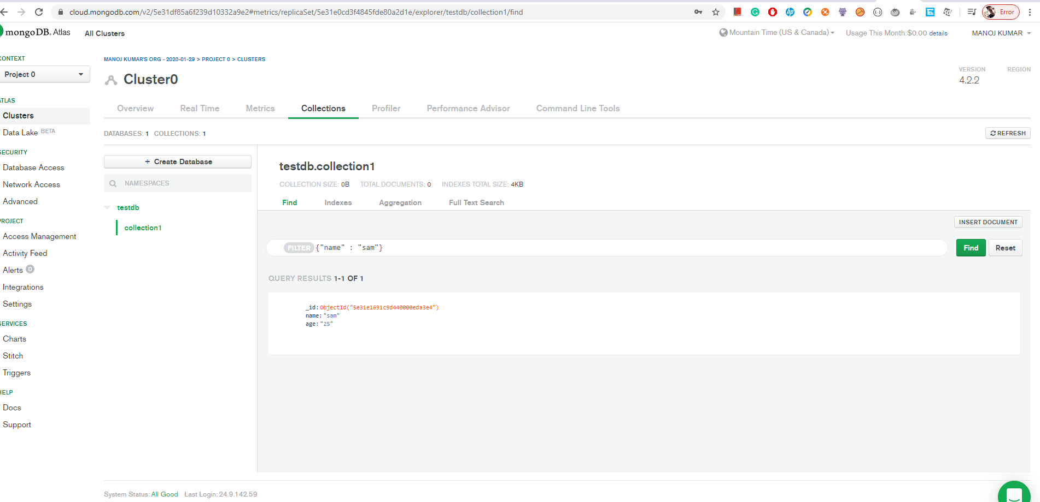

Created a database in MongoDB atlas and successfully run the queries.

**I acknowledge that this document can be supplied to USCIS in compliance with CPT/OPT/STEM OPT audit:**

**Output:**